OHM’S LAW

WORKSHEET
GOALS
- To confirm Ohm’s Law.

- To discover the resistance of an unknown resistor.

- Draw the V – I curve.

DISTANT ACTIVITY
- Connect with the site: http:// e-science.web.auth.gr/circuits
- Click on the tab “Experiment” and connect with your own username and password (if you do not have you can sign in)
- Choose experiment 6 (Ohm’s Law)
- Choose voltage from 0 to 4,12volts and fill in the matrix I

Matrix I
# | Voltage  (Volt) | Electric Current  (mA) | Ratio  V / I
1 | V₁= | I₁= | ($\frac{V}{I})$₁=
2 | V₂= | I₂= | ($\frac{V}{I})$₂=
3 | V₃= | I₃= | ($\frac{V}{I})$₃=
4 | V₄= | I₄= | ($\frac{V}{I})$₄=
5 | V₅= | I₅= | ($\frac{V}{I})$₅=
6 | V₆= | I₆= | ($\frac{V}{I})$₆=
7 | V₇= | I₇= | ($\frac{V}{I})$₇=
8 | V₈= | I₈= | ($\frac{V}{I})$₈=
9 | V₉= | I₉= | ($\frac{V}{I})$₉=
10 | V₁₀= | I₁₀= | ($\frac{V}{I})$₁₀=
Mean Value |  |  | ($\frac{V}{I})$_{M.V.}=$\frac{\left(\frac{V}{I}\right)1+\left(\frac{V}{I}\right)2+\left(\frac{V}{I}\right)3+\left(\frac{V}{I}\right)4+\left(\frac{V}{I}\right)5+\left(\frac{V}{I}\right)6+(\frac{V}{I})7+(\frac{V}{I})8+(\frac{V}{I})9+(\frac{V}{I})10}{10}$

DATA ANALYSIS
- Place the (V,I) values from Matrix I on the diagram below
- Draw the V – I curve which better fits the points.

- The curve which better fits the points on the diagram seems to be
- Straight line | - Parabola | - None of the previous
- From the values that I have calculated, I believe that the ratio V/I
- Increases | - Decreases | - Remains Constant

With a similar way a German Physicist Georg Simon Ohm (1789 - 1854), observe that Electric current (I) in a metal conductor is proportional to the applied voltage and thus the ratio V/I remains constant.
This ratio (V/I) was named by Ohm resistance R (R=V/I) of the conductor and nowadays is measured in Ohm (Ω) units after Georg Simon Ohm.

THINK
a1. Are all values or V/I ratio that you have calculate in matrix I close enough with each other, so as to consider that all values are accepted?
i. YES ii. NO

a2. If not, which value(s) you would exclude (from the Mean Value)

b. The V/I variations you come up to where do you believe they derive from?
i. the V/I ratio varies as we vary the voltage
ii. in real experiments there are always deviations in values as a result of a numerous reasons

c. If we raise the voltage to 5Volt what would you expect to happen at the resistance of the conductor (R) (R=V/I)
i. remain almost the same ii. increase iii. decrease

d. A classmate of yours constructed the V-I diagram below using the circuit in figure 1. Can you calculate the value of the unknown resistance (R)?
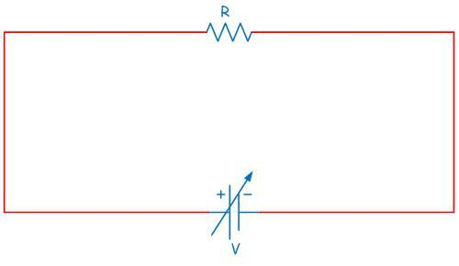
Α

Figure 1

Help us to improve ourselves!
Answer to the questionnaire!

