RESISTORS IN PARALLEL

WORKSHEET
GOALS
- To confirm that resistors (R₁, R₂) in parallel are equivalent with a resistor (R_{tot}) of total resistance which is given by the formula $\frac{1}{R_{ολ}}=$ $\frac{1}{R_{1}}+ \frac{1}{R_{2}}$.
DISTANT ACTIVITY
- Connect with the site: http:// e-science.web.auth.gr/circuits
- Click on the tab “Experiment” and connect with your own username and password (if you do not have you can sign in)
- Choose experiment 4 (Resistors in Parallel)
- Choose voltage from 0 to 4,12volts and fill in the matrix I

Matrix I
# | Voltage  (Volt) | Electric Current  (mA) | Resistance $(R=\frac{V}{I})$  (KΩ)
1 | V₁= | I₁= | R₁=
2 | V₂= | I₂= | R₂=
3 | V₃= | I₃= | R₃=
4 | V₄= | I₄= | R₄=
5 | V₅= | I₅= | R₅=
6 | V₆= | I₆= | R₆=
7 | V₇= | I₇= | R₇=
8 | V₈= | I₈= | R₈=
9 | V₉= | I₉= | R₉=
10 | V₁₀= | I₁₀= | R₁₀=
Mean Value |  |  | R_{M.V.}=$\frac{R_{1}+R_{2}+R_{3}+R_{4}+R_{5}+R_{6}+R_{7}+R_{8}+R_{9}+R_{10}}{10}$
DATA ANALYSIS
If R₁=R₂=1000Ω then which of the follow describes better the relationship between R_{M.V.} , R₁ and R_{2.}
a. R_{M.V.} = R₁+R₂ b. R_{M.V.} = R₁ – R₂
c. R_{M.V.} = R_{1∙}R₂ d. R_{M.V.} = $\frac{R_{2}}{R_{1}}$
ε. $\frac{1}{R_{M.V.}}=$ $\frac{1}{R_{1}}+ \frac{1}{R_{2}}$
THINK
a. As you can see in figure 1 the two resistors are connected in parallel. If it is given that R_{tot}=20Ω, and R₂=30Ω, calculate the resistance of R_{1.}

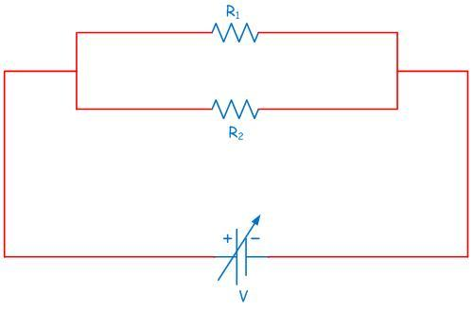
Α

b. Total resistance of two resistors connected in .................... satisfies the formula .................... and it is always .................... (lower/greater) from the lowest resistor that we have used.

Help us to improve ourselves!
Answer to the questionnaire!

