RESISTORS IN SERIES

WORKSHEET
GOALS
- To confirm that resistors (R₁, R₂) in series are equivalent with a resistor (R_{tot}) of total resistance which is given by the formula R_{tot}=R₁+R₂.

DISTANT ACTIVITY
- Connect with the site: http:// e-science.web.auth.gr/circuits
- Click on the tab “Experiment” and connect with your own username and password (if you do not have you can sign in)
- Choose experiment 5 (Resistors in Series)
- Choose voltage from 0 to 4,12volts and fill in the matrix I

Matrix I
# | Voltage  (Volt) | Electric  Current  (mA) | Resistance $(R=\frac{V}{I})$  (KΩ)
1 | V₁= | I₁= | R₁=
2 | V₂= | I₂= | R₂=
3 | V₃= | I₃= | R₃=
4 | V₄= | I₄= | R₄=
5 | V₅= | I₅= | R₅=
6 | V₆= | I₆= | R₆=
7 | V₇= | I₇= | R₇=
8 | V₈= | I₈= | R₈=
9 | V₉= | I₉= | R₉=
10 | V₁₀= | I₁₀= | R₁₀=
Mean Value |  |  | R_{M.V.}=$\frac{R_{1}+R_{2}+R_{3}+R_{4}+R_{5}+R_{6}+R_{7}+R_{8}+R_{9}+R_{10}}{10}$
DATA ANALYSIS
If R₁=R₂=1000Ω then which of the follow describes better the relationship between R_{M.V.} , R₁ and R_{2.}
α. R_{Μ.V.} = R₁+R₂ β. R_{Μ.V.} = R₁ – R₂
γ. R_{Μ.V.} = R_{1∙}R₂ δ. R_{Μ.V.} = R₁ /R₂

THINK
a. In figure 1 you can see a circuit which has two resistors, an ammeter and a voltage source. If R_{tot}=17Ω and R₂=9Ω calculate the resistance of resistor R₁.

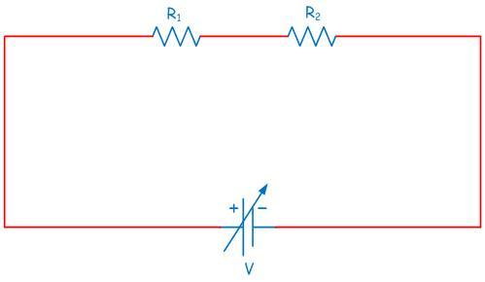
Α
b. Total resistance of two resistors connected in .................... satisfies the formula .................... and it is always .................... (lower/greater) from the resistor with the greater resistance that we have used.

Help us to improve ourselves!
Answer to the questionnaire!

